Introduction

Overview

This project is a simple demonstration of plasma donor application. It is developed in Oracle workspace

using fundamentals of SQL queries and the aggregate functions. It also makes use of forms and extraction

of data from them to store in our databases, generate graphs as well as pie chart for a simpler presentation.

The main page or the Home Page holds a logo of our application naming it. We have several other pages for

various other functionalities. Our pages serve these following properties:

Donor Registration

Search for a donor

A graphical representation of collected data

Donor Registration requires an individual to fill up important personal details like email,

phone no, etc. and then the record is added to thee database. Next Page has provide the facility to look for

a particular donor and adds several filters to be performed on our data based on one's requirements. The

last page depicts a bargraph of infected individuals data and a pie-chart for depicting donor's data.

Purpose

The purpose for creating this application is to make it hassle-free for the people who are in need of a certain

group. It makes it easy for look for a certain blood group. Moreover it maintains a dataset of all samples

collected from different people and in similar way it is utilised by other needy people by making use of

search donor functionality which is rather effective and time saver. This can be improved even better by

making the UI more better and improving the quality of records we maintain.

Block diagram

Hardware/Software Requirements

CPU: 1.6 GHz for web, 4 x 1.6 GHz for database

RAM: 4GB

Minimum Database Space: 10GB

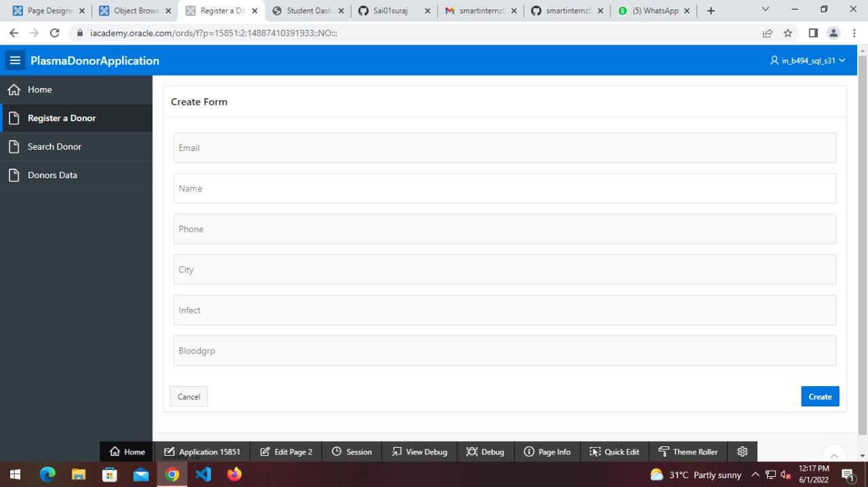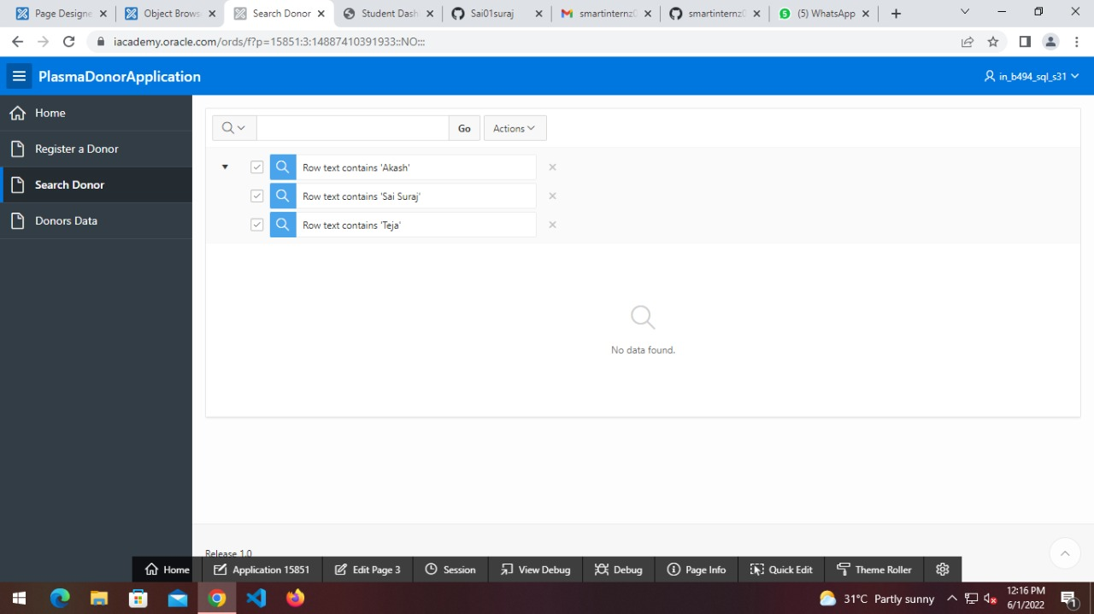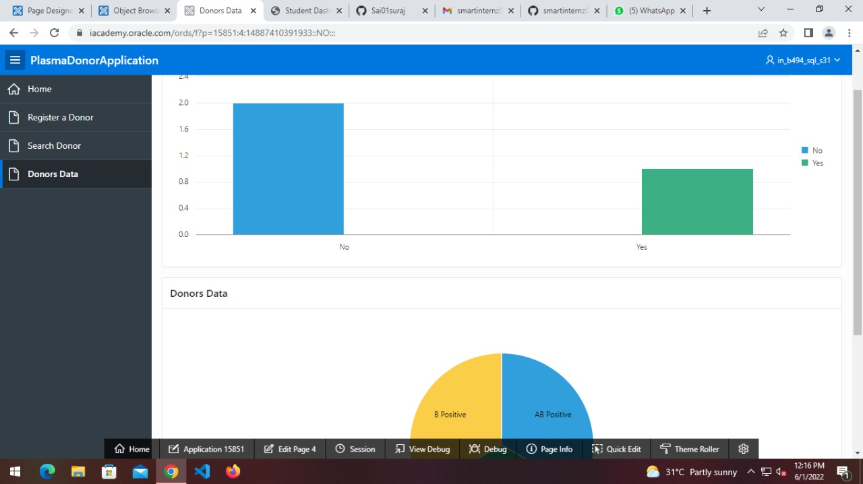

Applications of Plasma Donor Application

The applications of the plasma donor application are as follows:

Availability lookup for different blood groups

Hassle free and time saving

Makes emergency situations feasible

Conclusion

This application serves as a bridge between the needy and cure. It is mainly developed for the people living

in rural areas to make use of it in maintaining records of groups available in a region.Hence it is quite

beneficial for people to know more about it and how it helps in serving a broad category of patients in needy

of blood tranfusion.

Future Scope

Following changes can be made to improve the application even better:

Improving the UI

Maintaining even more details about a donor

Quality records management

can be added locations of availaibility

Making it more efficient to deal a large collection base

can be made better by adding a feature like prediction of diseases.

Appendix

The source code of the application is available on the following github page

link:[https://github.com/smartinternz02/SPS-11974-Plasma-Donor-Application.git](https://github.com/smartinternz02/SPS-11900-Plasma-Donor-Application.git)

Workspace : IN_B494_SQL_S31

Username : IN_B494_SQL_S31

Password : 9908862058@sAi